
Lab Number: 1 Date:2025/05/13
Title: Understanding the basic network equipment

THEORY:
- Repeater:
Repeaters are network devices operating at the physical layer of the OSI model that regenerate an incoming signal before retransmitting it.
Function: Repeater retransmits weakened signals to overcome attenuation, helping extend the range of LANs or cellular networks.
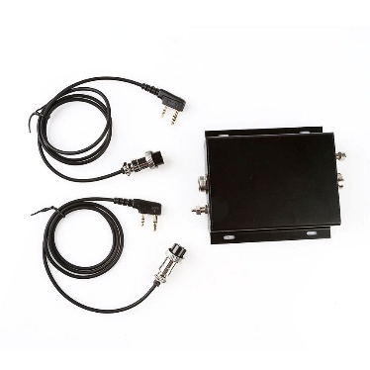

Fig: Repeater
- Hub:
A hub is a physical layer networking device which is used to connect multiple devices in a network. They are generally used to connect computers in a LAN.
Function: A hub connects multiple computers and broadcasts incoming data to all ports, regardless of the destination.
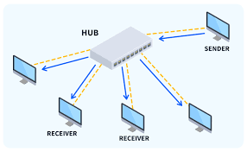

Fig: Hub
- Switch:
A switch is a data link layer networking device which connects devices in a network and uses packet switching to send and receive data over the network.
Function: A switch, like a hub, has many ports, but it sends data only to the intended device by checking the destination address, supporting unicast and multicast.
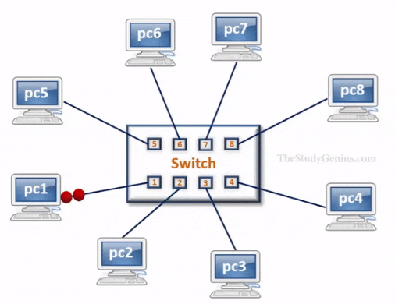
Fig: Switch
- Bridge:
Bridges are the devices used to connect two subnetworks that use interchangeable protocols. It combines two LANs to form an extended LAN.
Function: They filter data based on destination or MAC addresses to ensure efficient routing.
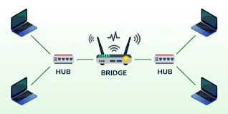
Fig: Bridge

- Router:
Routers are the devices responsible for receiving, analyzing, and forwarding data packets among the connected computer networks
Function: The router receives the packets from its input ports, checks its header, performs some basic functions like checksum, and then looks up to the routing table to find the appropriate output port to dump the packets onto, and forwards the packets onto that output port.
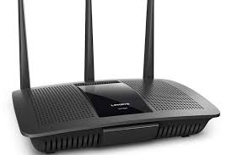
Fig: Router
- Modem:
Modem stands for Modulation Demodulation. A modem converts the digital data signals into analogue data signals.
Function: The main function of a modem is to convert the analog signals that come from telephone wire into digital form. In digital form, these converted signals are stored in the form of 0s and 1s.

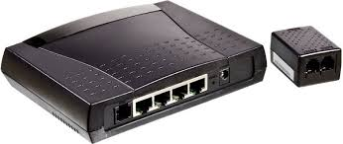
Fig: Modem

- Network Interface Card:
A network interface card (NIC) is a hardware component without which a computer cannot be connected over a network.
Function: NIC allows communications between computers connected via local area network (LAN) as well as communications over large-scale network through Internet Protocol (IP).

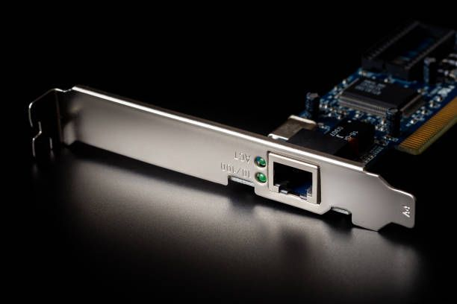
Fig: Network Interface Card
- Firewall:
A firewall is a type of network security device that filters incoming and outgoing network traffic with security policies that have previously been set up inside an organization.
Function:
A firewall's primary function in a computer network is to act as a security barrier, monitoring and controlling network traffic based on predefined rules to protect against unauthorized access and malicious threats.

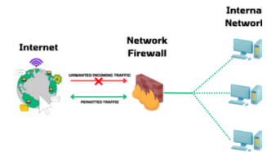

Fig: Firewall

- Wireless Access Point (WAP):
The Wireless Application Protocol (WAP) is a set of communication protocols and an application programming model based on the World Wide Web (WWW).
Function: A WAP enables wireless devices to connect to a wired network

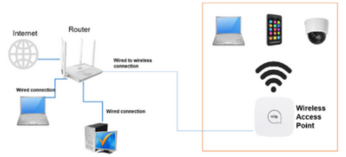

Fig: Wireless Access Point
- VoIP Endpoint:
VoIP (voice over Internet Protocol) is the transmission of voice and multimedia content over an internet connection.
Function: A VoIP service will convert a user's voice from audio signals to digital data, then send that data through the internet
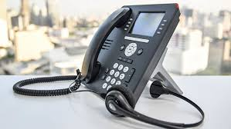
Fig: VoIP Endpoint

CONCLUSION:
In this lab, we examined important network devices found in computer networks, including repeaters, hubs, switches, bridges, and routers, along with their functions in transmitting data. We also discussed advanced equipment like modems, firewalls, wireless access points (WAPs), and VoIP systems, which support internet connectivity, security measures, and voice communications. Gaining knowledge of these devices is crucial for designing, managing, and troubleshooting networks that are efficient and scalable.

